Chapter 3, Problem 65.

Use MATLAB to solve for the mesh currents in the circuit of Fig. 3.109.

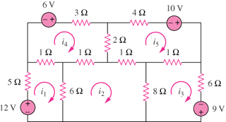

Figure 3.109
For Prob. 3.65.

